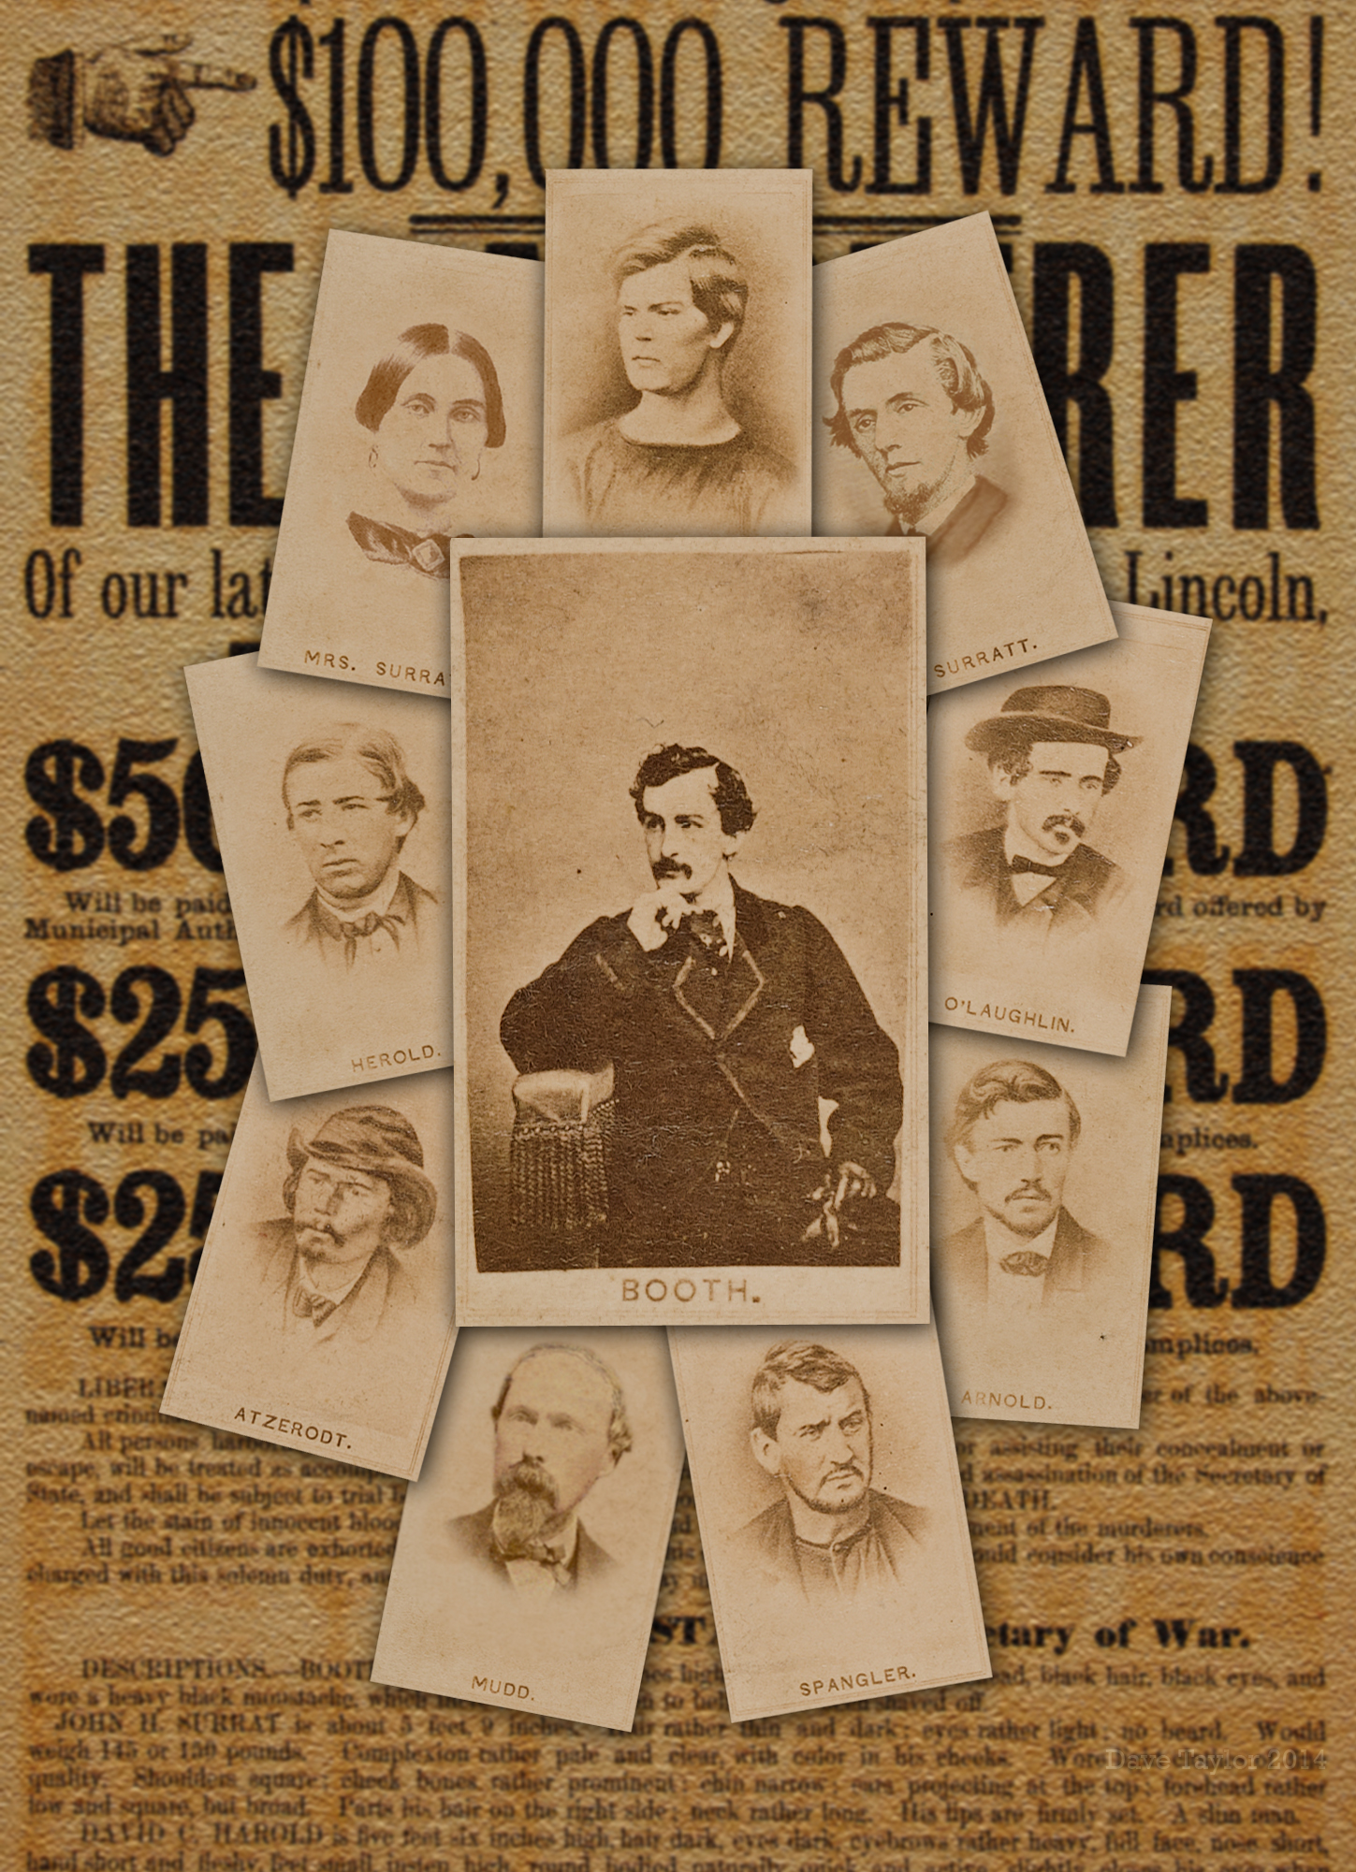  July 9, 2018  The Lincoln Assassination Conspiracy Trials and their Aftermath  Civil War Round Table of North East Indiana  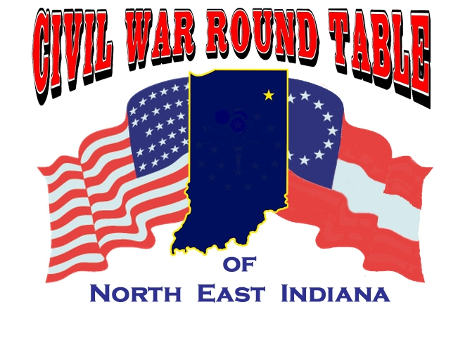 | Hon. Roger B. Cosbey  ────  Local Judge explores the trials  ────  What was Mary Surratt’s role?  ────  Was it a fair trial?  ────  Find the answers here  Allen County PUblic LIbrary, downtown  900 Library Plaza  6:30 pm to 8:30 pm  Globe Room

