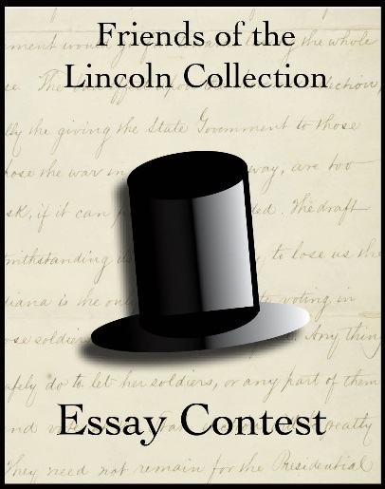
Third Annual
Friends of the Lincoln Collection
High School Essay Contest

The Lincoln-Douglas Debates

Essay Prompt: The Lincoln-Douglas debates were a series of debates between Abraham Lincoln and Stephen Douglas. Lincoln was running for U.S. Senate as a Republican candidate against Douglas who was the incumbent Democratic senator. These debates covered numerous topics important to the candidates and their platforms for election. Using at least 4 primary sources from the Lincoln Financial Foundation Collection (suggestions of primary sources can be found under the “Essay Contest” tab at www.friendsofthelincolncollection.org), formulate an original response to this prompt:
Compare and contrast 1) the role of the media, 2) the candidate’s individual influence, and 3) the issues/topics used to persuade voters during the Lincoln/Douglas Debates 160 years ago in 1858 to the methods practiced in today’s campaigns.

Essay Requirements: 1,500-2,500 words

Historical Timeline
The Lincoln Douglas debates took place in seven towns across Illinois in 1858:
Ottawa on August 21
Freeport on August 27
Jonesboro on September 15
Charleston on September 18
Galesburg on October 7
Quincy on October 13
Alton on October 15

Eligibility: Indiana High School Students.

Prizes: $1,000 for first place, $500 for second place, and $250 for third place.

Judging: Individuals designated by the Friends of the Lincoln Collection board will be the sole and exclusive judges. Winners will be announced in December.

Submission: Essays must be received by November 9, 2018. Include your name, age, grade, and school. File name should be as follows: “YourLastName_FirstName_Lincoln.” (ie. Smith_John_Lincoln) Submit online at www.friendsofthelincolncollection.org under the “Essay Contest” tab.

For More Information: Send inquiries to lincoln@acpl.info

