Friends of the Lincoln Collection
Essay Contest Rubric
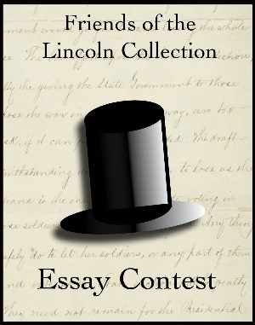

Fall 2018 “The Lincoln-Douglas Debates”

Essay Prompt: Compare and contrast 1) the role of the media, 2) the candidate’s individual influence, and 3) the issues/topics used to persuade voters during the Lincoln/Douglas Debates 160 years ago in 1858 to the methods practiced in today’s campaigns.

Category | Points
Answers the prompt in a clear and coherent manner. | 0 1 2 3
Uses primary sources | 0 1 2 3
Evidence of research | 0 1 2 3
Quality of argument | 0 1 2 3
Writing Mechanics | 0 1 2 3

Grading Scale
3- Expectation was met
2- Expectation was not entirely met
1- Expectation was attempted, but not met
0- Expectation was not attempted

