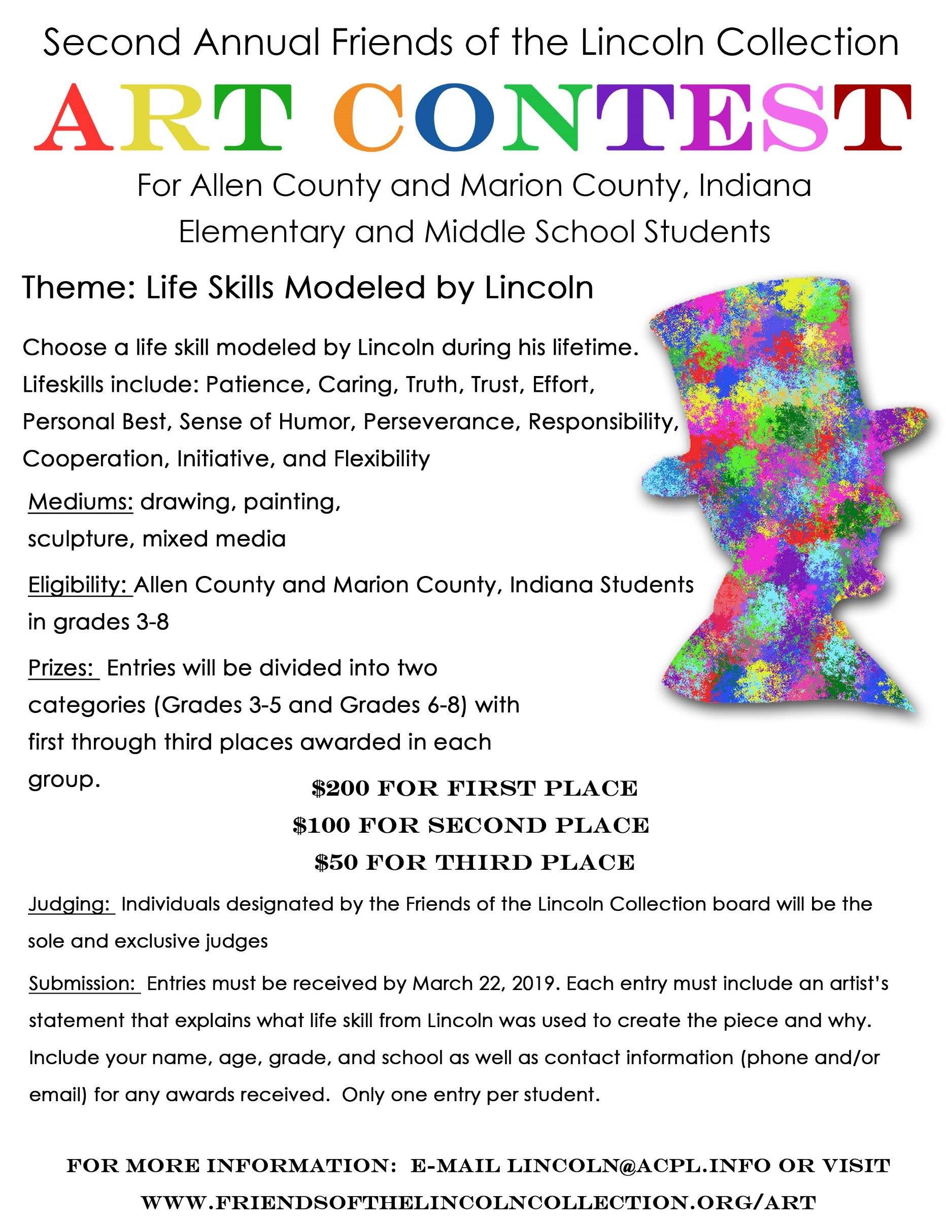

Second Annual Friends of the Lincoln Collection Art Contest
Artist’s Statement

Name: ___________________________________________________________

Grade: _________ Age: _________

School: __________________________________________________________

Artist’s Statement:

________________________________________________________________________________________________________________________________________________________________________________________________________________________________________________________________________________________________________________________________________________________________________________________________________________________________________________________________________________________________________________________________________________________________________________________________________________________________________________________________________________________________________________________________________________________________________________________________________________________________________________________________________________________________________________________________________________________________________________________________________________________________________________________________________________________________

